**Project Report**

**Project Title:** **Pharmacy Management System**

**Course Name**: Software Engineering & Information System Design

**Course Code**: CSE411

**Section No**: 02

**Submitted To**:Dr. Mohammad Salah Uddin

Assistant Professor

Department of CSE

East West University

**Submitted By:** Name: Md. Tanvir Parvez

ID: 2017-2-60-088

Name: Md. Atiqur Rahman

ID: 2017-2-60-087

**Date of Submission**: **18.04.2022**

Problem Statement

In the Pharmacy Maintenance System, we can avoid the difficulty of maintaining the medicine details and bill details. Manual handling of records creates many problems. Maintaining the records of each medicine and patient of a pharmaceutical store is tedious work. Generating various reports also becomes very tedious. It becomes complicated in big medical stores to handle the details of all the medicines manually.

Proposed Solution

To overcome the above problems, the current project has been developed. The proposed system is an offline management System that improves the maintenance and manipulation of the drugs in the pharmaceutical stores.

An efficient pharmacy management system can make the work easier by giving the details of the medicine when its name is entered. The computer gives details of the medicine like the rate of medicine and the expiry date. However, it becomes complicated to handle the details of all the medicines manually. So, by using this pharmacy management system, we can maintain the records of all the medicines.

Pharmacy Management system are employed in regulatory control and drug management, community pharmacy, hospital pharmacy, the pharmaceutical industry, academic activities, and training of other health workers. The Pharmacy Management system is employed in regulatory control and drug management. The pharmacy information system is usually used to support activities and inventory. The pharmacy management system is used to minimize the time and resources by maintaining the details of the drug systemically so that the data can be used in the quickest possible time. At the same time, the resources which are minimized are the workforce, money, paper, etc. The system is user-friendly and will help the pharmacist. This system will reduce the burden on pharmacists and make the system efficient by providing more accurate details about drugs in the medical.

Feasibility Studies:

The goal of the feasibility study is to find reasons for producing software that is user-friendly, customizable and conformable to established standards. Feasibility can be divided into three types. Technical, operational, and financial feasibility are the three types of feasibility.

* **Technical Feasibility:**

Technical feasibility assesses current technologies that are required to meet client needs on schedule and within budget. We use modern technologies. We ensured that the system is well-designed so that the consumer will find it simple to use. The system is currently only accessible on the web. Employees can add suppliers and customers. They can also update data if needed.

* **Operational Feasibility:**

Operational feasibility looks at how well the required software can solve business problems and meet customer needs. Our system was built with PHP and MySQL, and it didn't take long for the data to reload and be shown. It is difficult labor to manually handle records and keep track of each drug and patient. Our system is an offline management system that improves drug storage and manipulation. So that the data may be accessed as quickly as feasible, the pharmacy management system maintains drug details systemically.

* **Economic feasibility:**

Economic feasibility determines if a software can create a profit for a company. Because this system minimizes manual effort and the use of paper and ink, it lowers the cost of paper, pen, and labor.

***Requirement Analysis:***

There are functions done by the system such as: store the necessary information of drugs, prepare bill for the medicine, give report easily searching of medicine, update, delete and save data of medicine.

***Functional requirements:***

1. View Dashboard: the end user can see all the necessary information on the dashboard and quickly access any information that they want to see.
2. The end user can see all customers, search for a particular customer, add new customers, edit customer information, delete customer.
3. The user can view all Medicine, search a particular medicine, add medicines the detail information about each medicine including actual name, generic name, formula, the price, how many of them are available, their expire date and supplier, End user can also Edit medicine information and Delete medicine information.
4. The user can see all Suppliers, search a particular supplier, Add Supplier information their name, email, phone, address. Edit Supplier information and Delete Supplier.
5. View all Sales, search a particular sale, add new Sale through invoice by searching medicine, Edit Sale, and Delete Sale.
6. The user can see all Purchases, search a particular purchase, and add new Purchase, Edit Purchase, and Delete Purchase
7. The user can View Sales and purchase report and also print them.

***Non-Functional requirements:***

1. The software is very reliable.
2. It is a very secure system, only the user with a username and password can use it.
3. Each search for particular information takes less than 2 seconds.
4. The usability of the application is very easy.
5. It is easy to maintain.

Software Requirements:

* Operating System – Windows
* Front End – PHP, HTML, CSS, JavaScript
* Back End – MySQL
* Editor Tools – Notepad++, Sublime
* Other Graphics Tools – Adobe Photoshop
* Web Browser – Google Chrome, Firefox.

Project Develop Languages

* Programming Language & Markup Language: PHP, JavaScript, HTML
* Color Script Language: CSS
* Database Language: MySQL

***UML use case diagram:***

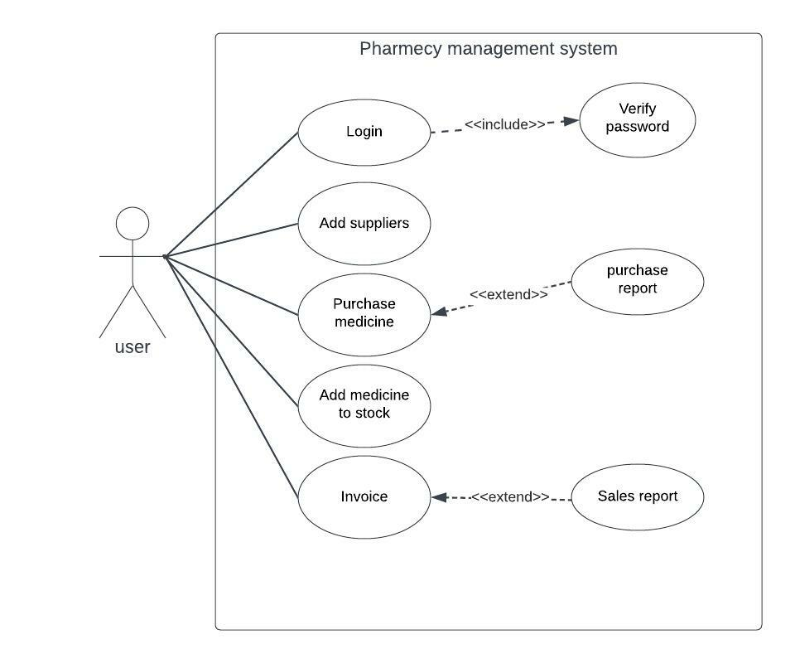

UML Class Diagram:

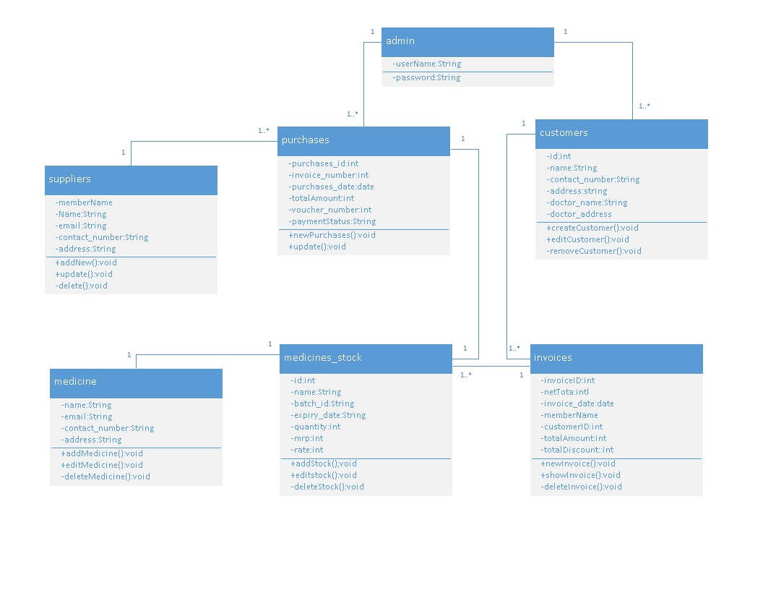

ER Diagram:

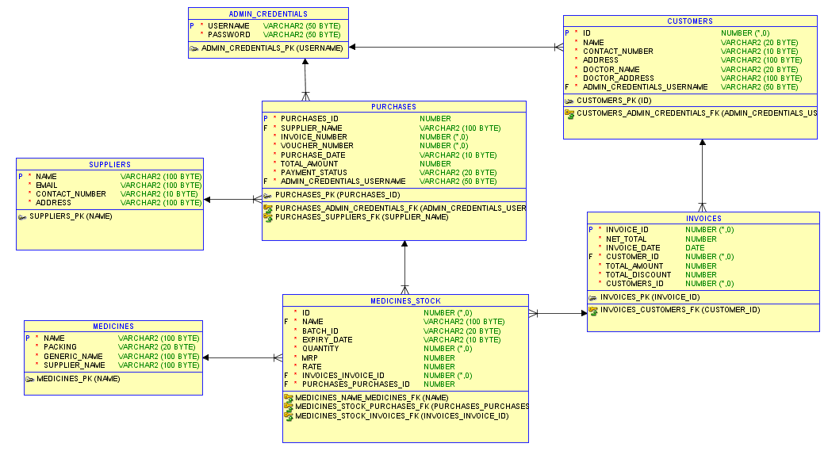

***UML sequences diagram:***

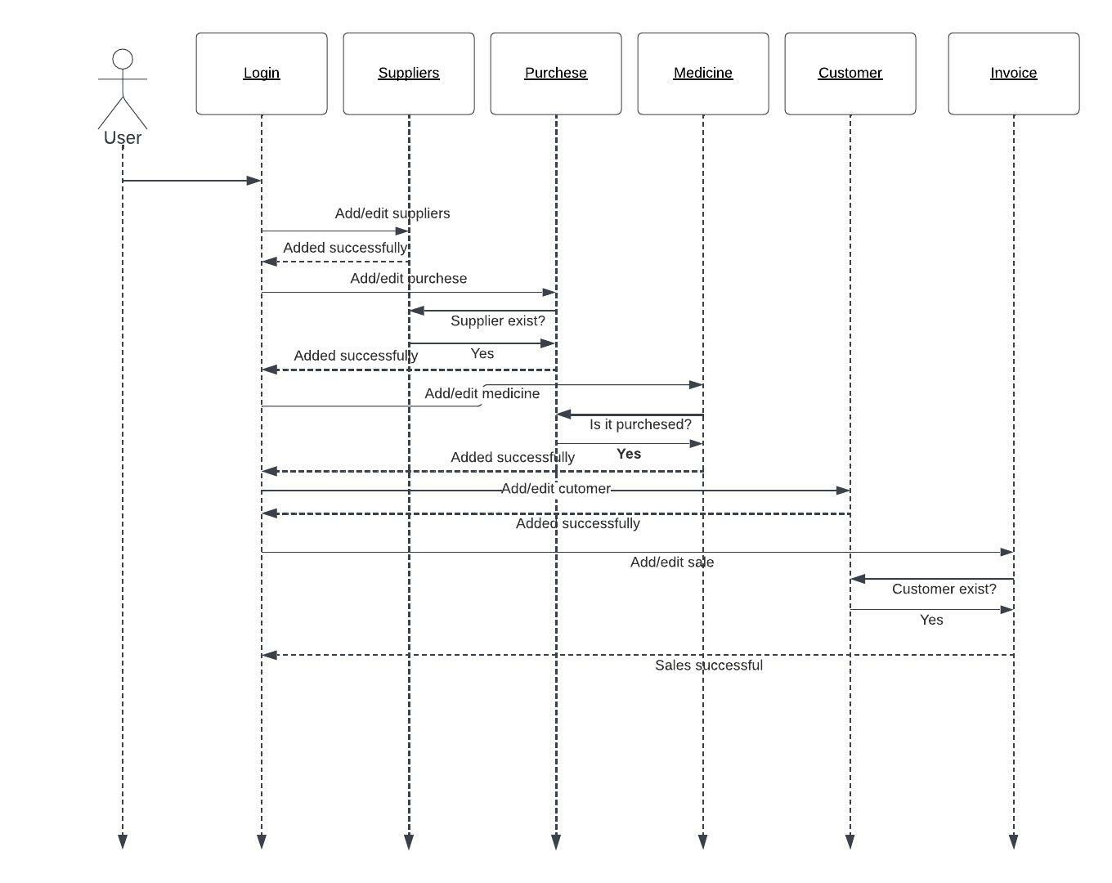

Test Case (white box method):

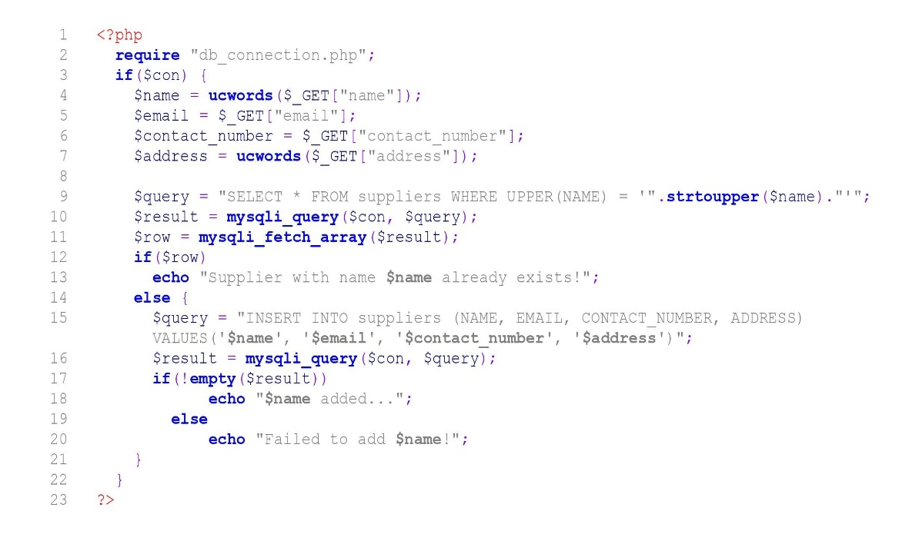

Control Flow Graph for Source Code

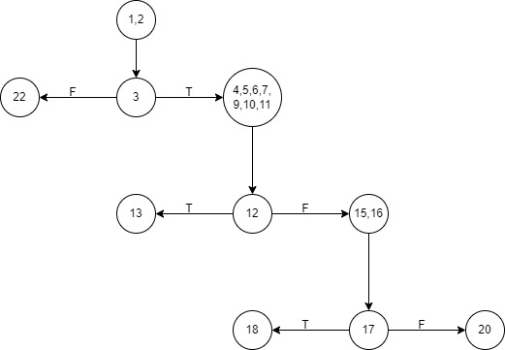

Testing:

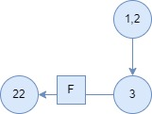

Testcase: Database Error

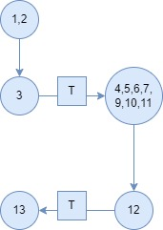

Testcase: Square [Supplier already present in supplier table]

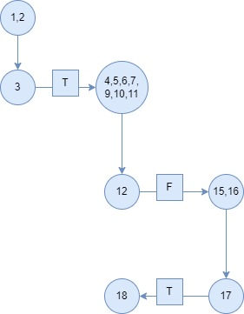

Testcase: Medico [Successfully added]

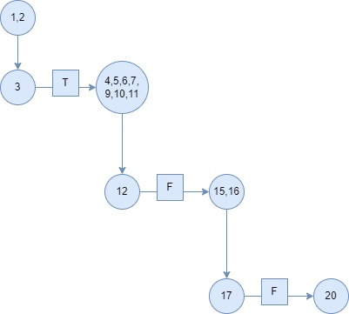

Testcase: medico [failed to added in database]